University of Technology Sydney

31260 Interface Design

Assignment 3

Interface Development and Implementation

Authors:

Chi Kit Chan (ID 11301506)

Ka Hei Chan (ID 11301239)

Table of contents

Goal 3

Scenario 3

User story 3

Design rationale of first prototype 3

Heuristic evaluations of prototype 1 5

Test methodology 5

Findings 5

1. Popup notification has no preview 5

2. “>>” for read more in news preview is misleading 5

3. Missing system feedback in news following 5

5. Category filter in menu page is messy 6

Design of the second prototype 7

Conclusion 7

Appendix 8

Screenshot of first prototype 8

Screenshot of second prototype 13

Evaluation evidence 13

Sketch of original prototype 14

# Goal

The selected goal of the design is “Catching up on news from around the world”.

# Scenario

It is in the year 2024 on a Monday morning in Sydney, Tex is on his way to his workplace as usual. Tex’ office is situated far away from his home. It takes a long time to travel. Tex would like to use the travelling time to read the latest news. He is particularly interested in world affairs and sport news. Currently it is during NBA season, Tex is a fan of the basketball team Chicago Bulls so he would like to catch up news about their latest matches and events. Besides the tension of Cold War 2 is growing, Tex is very worried about the situation.

# User story

Tex wants to read and follow interesting news highlights from around the world while on his way to work.

# Design rationale of first prototype

The design project is to design and produce a high fidelity prototype of the application for Tex to achieve the goal.

The high-fidelity prototype started by following the sketch of screens from the previous paper prototype design (see appendix). Also taking considerations from the previous evaluations of the paper prototype. However, due to technical constraints, some feature couldn’t be implemented, such as the news category filter dropdown list, as well as different appearance than the paper prototype. As a result, the high-fidelity prototype mostly follow the original design, but with some minor adjustments. Screenshots of the prototype is attached in appendix.

The design uses web technology such as HTML, CSS, JavaScript to build a set of web pages that mimic a mobile phone and the application. The starting point of the prototype is “home.html” file. Bootstrap CSS framework is used for layout and styling. Leaflet JS library is used to build the interactive world map.

The design uses standard elements such as navigation bar, home button, menu buttons, back button, as well as the common icon set. The buttons and hyper links are styled following common design, such as blue text for links, rounded 3D buttons. Page title is displayed on top in a title bar. Therefore, most users should be able to know how to navigate through the application.

The World map for displaying world news uses an interactive real world map. It allows user to zoom in or out, pan in every direction. News highlights image thumbnails are displayed as bubbles on the map pinned to the right location on the map. The design allows users to view news from around the world, and have a clear idea where they take place easily.

It is also worth pointing out that the popup dialog in our design is meant to simulate a projected virtual screen by a portable projected built-in the phone, we expects it to be possible in the year 2024.

# Heuristic evaluations of prototype 1

## Test methodology

Several user evaluations were carried out to help to evaluate the prototype. One user was invited to participate in the test. Wizard of Oz technique is used, where the user will be shown the prototype and invited to interaction with the system to perform the task. User’s actions and opinions were recorded and then Nielson’s Heuristics is applied to evaluate the prototype.

## Findings

### 1. Popup notification has no preview

In user evaluation, the user suggested that a preview of the news content within the push notification would be nice. A preview would allow the user to get more idea of the news at a glance without the need to open up the newsreader application. This would be a violation to the Recognition rather than recall, and flexibility and efficiency of use heuristics. See Figure 16.

### 2. “>>” for read more in news preview is misleading

During the evaluation the User does not notice the “>>” represents the link to the news page at the beginning. The user reflected that this is hard to understand. This could be a violation to the Match between the system and the real world, efficiency of use heuristics. (See Figure 3, 4)

### 3. Missing system feedback in news following

When the user pressed on the Follow button in news page, there is no feedback from the system that indicates something has happened. This would be a violation to the Visibility of system status and information feedback heuristics, and possibly Error Prevention as well, as the user may think the system didn’t work and repeat the click, making him un-follow instead of follow.

4. The interface is not fully updated after sport news is selected

It is found that when the user applied the sport filter, only the world map has been updated but headings and news highlight still remain, displaying not only sport news. This can be a violation to Match between the system and the real world.

(See figure. 4)

### 5. Category filter in menu page is messy

The user reported that the Category filter page is poorly designed. Particularly, the category screen also shows the news headline while it is not needed at all. This is a violation to Efficiency of use, and Aesthetic and minimalist design heuristics.

(See figure. 5)

# Design of the second prototype

The second prototype is made to respond to usability issues discussed in the user evaluation. Below is a list of the improvements that address the issues.

……………………..

# Conclusion

The outcome of this project is the high fidelity prototype of the design of the newsreader application for Tex to archive the goal of reading news from around the world.

The biggest feature of the design we think is the world map interface to display news headlines form around the world and allow users to interact with it in a very intuitive way. And also the ability to project article using mobile projector to provide a bigger “screen” for users to read news, this should allow Tex to read much more easier.

# Appendix

## Screenshot of first prototype

|  |  |
| --- | --- |
| E:\UTS\Github\interfacedesign-prototype\doc\phonehome.PNG  Figure OS home screen | E:\UTS\Github\interfacedesign-prototype\doc\home.PNG  Figure App home screen |
| Figure World news with hot topic at bottom | Figure world news with headlines in bottom |
| Figure news category filter | Figure world news with sport filter |
| Figure News page | Figure news page |
| E:\UTS\Github\interfacedesign-prototype\doc\mjdie.PNG  Figure news page | Figure push notification preview projection (first) |

## Screenshot of second prototype

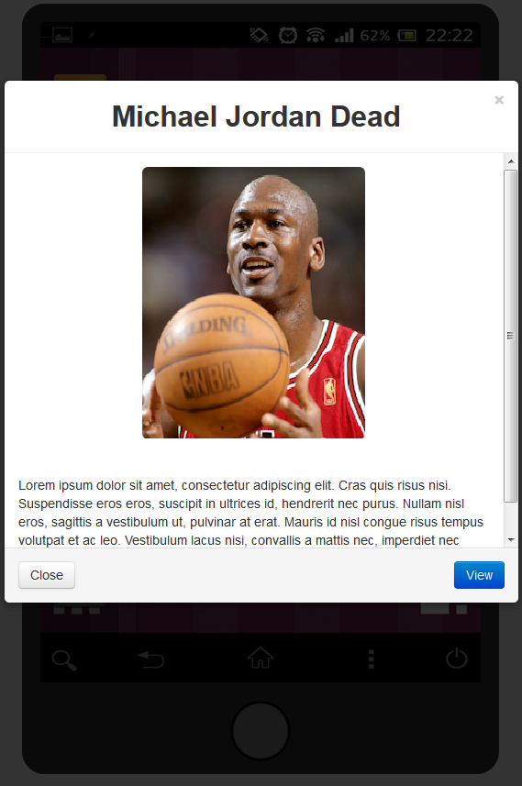

Figure Push notification preview projection (second)

## Evaluation evidence

## Macintosh HD:Users:nelson:Documents:Academics:UTS:2013-autumn:31260 Interface Design:assign2:Prototype:sketch-eval:DSC_0352.jpgSketch of original prototype